The Islamia University of Bahawalpur
Department of Information Technology



SOFTWARE REQUIREMENTS SPECIFICATION
(SRS DOCUMENT)
Tour Guiding Agency – Online Platform for Tour Planning & Booking
Submitted by Muhammad Zohaib Zafar
Registration No: F22BINFT1E02099
Submitted to Ms. Sara Fareed
Department of Information Technology
Faculty of Computing
The Islamia University of Bahawalpur
Date: 5 December, 2025

Summary
This document presents the complete Software Requirements Specification (SRS) for the “Tour Guiding Agency” – a modern, full-stack web application built using the MERN stack. The platform acts as a digital travel marketplace that connects travelers with verified local tour guides, travel agencies, and curated tour packages across Pakistan and internationally. The system eliminates the traditional hassle of contacting multiple agents via calls/WhatsApp by providing a centralized, transparent, and real-time booking platform. Users can explore tours by destination, duration, budget, group size, and activities; read reviews; compare prices; and complete secure bookings online. Tour guides and agencies get a powerful dashboard to manage their listings, availability, bookings, and earnings.

Table of Contents
- Introduction 1.1 Purpose 1.2 Scope 1.3 Product Perspective 1.4 User Characteristics 1.5 Similar Apps & Literature Review 1.6 Proposed Technologies
- Requirements 2.1 Functional Requirements 2.2 Non-Functional Requirements
- Use Cases and Flow of Processes 3.1 Use Case Diagram (with Activity & Sequence Diagrams description)
- References

1. Introduction
Travel planning in Pakistan is still largely offline and fragmented. Tourists and locals waste hours calling different guides and agencies to check availability, prices, and itineraries. There is no trusted centralized platform where users can compare multiple verified tour operators in real time. The “Tour Guiding Agency” platform solves this problem by creating a TripAdvisor + Booking.com-like experience focused on guided tours and adventure packages.

1.1 Purpose
The main objectives of this project are:
- To develop a user-friendly online platform for discovering and booking guided tours.
- To provide verified tour guides and agencies a digital presence and booking management system.
- To enable secure online payments and instant confirmations.
- To implement a review & rating system to build trust in the community.
- To reduce communication gaps and bring transparency in pricing and availability.

1.2 Scope
In Scope:
- User registration & profiles (Tourist, Guide, Agency, Admin)
- Tour package creation and management by guides/agencies
- Advanced search & filters (location, price, duration, group size, activities, language)
- Real-time availability calendar
- Online booking with partial/full payment (Easypaisa, JazzCash, Card)
- Review & rating system
- Wishlist, notifications, booking history
- Admin dashboard for verification and analytics
Out of Scope (Future Enhancements):
- Flight & hotel integration
- Live tracking of guide during tour
- Mobile app (only responsive web for now)
- Multi-currency support

1.3 Product Perspective
This system will be an independent web platform but can later be integrated with hotel booking sites, ride-hailing apps, or government tourism portals. It fills the gap between generic travel sites (that don’t focus on guided tours) and local unorganized guides.

1.4 User Characteristics
User Type | Education Level | Technical Expertise | Frequency of Use
Tourist | Intermediate+ | Low–Medium | Occasional
Tour Guide | Matric+ | Medium | Daily
Travel Agency | Graduate | Medium–High | Daily
Admin | Graduate | High | Daily

1.5 Similar Apps & Literature Review
App Name | Strengths | Weaknesses
TripAdvisor | Huge database, reviews | Very few bookable guided tours
GetYourGuide | Excellent booking flow | Very few tours in Pakistan
Viator | Global reach | Expensive, less local flavor
Local Facebook/WhatsApp Groups | Cheap, local guides | No trust, no payment protection, no reviews
Our platform combines the trust of reviews (like TripAdvisor) with direct booking capability (like GetYourGuide) but focused on Pakistan and regional languages.

1.6 Proposed Technologies
Category | Technology
Frontend | React.js, Tailwind CSS / Bootstrap, React Router
Backend | Node.js, Express.js
Database | MongoDB (NoSQL)
Authentication | JWT + OAuth (Google)
Payment Gateway | Easypaisa, JazzCash, Stripe (test)
File Storage | Cloudinary / AWS S3
Hosting | Vercel (Frontend), Render/Heroku (Backend)
Others | Redux Toolkit, Axios, Nodemailer, Socket.io (future live chat)

2. Requirements
The system allows tourists to search and book tours, guides/agencies to manage their packages and availability, and admin to verify and monitor everything. Users can pay online, receive e-tickets, write reviews, and manage their bookings from personal dashboards.

2.1 Functional Requirements
FR001 – User Registration & Login
- Name: FR001
- Purpose: Allow users to create account and login securely
- Users: Tourist, Tour Guide, Agency, Admin
- Input: Name, Email, Password, Phone, Profile Picture, Role
- Output: JWT token, redirect to respective dashboard
FR002 – Tour Package Creation (Guide/Agency)
- Purpose: Guides/Agencies can create detailed tour packages
- Input: Title, Description, Duration, Price, Max Group Size, Included/Excluded, Itinerary (day-wise), Images, Available Dates
- Output: Tour listed after admin approval
FR003 – Advanced Tour Search & Filters
- Purpose: Help tourists find perfect tour
- Filters: Destination, Price Range, Duration, Group Size, Activities (Trekking, Cultural, Food, etc.), Language of Guide, Rating
- Output: Filtered tour cards with images and short info
FR004 – View Tour Details
- Purpose: Show complete tour information
- Output: Gallery, itinerary, inclusions, reviews, guide profile, availability calendar
FR005 – Booking & Payment
- Purpose: Secure booking with online payment
- Input: Selected date, number of persons, special requests
- Payment: Easypaisa, JazzCash, Card (partial or full)
- Output: Booking confirmation + PDF ticket via email/WhatsApp
FR006 – Booking Management Dashboard
- Users: Tourist → My Bookings; Guide/Agency → Upcoming/Past Bookings
- Actions: View, Cancel (with refund rules), Download Invoice
FR007 – Review & Rating System
- Purpose: Only users who completed tour can review
- Input: Star rating (1-5) + written review + photos
FR008 – Admin Verification & Dashboard
- Admin can approve/reject guides, agencies, agencies and tour packages
- View analytics: total bookings, revenue, top guides, monthly growth
FR009 – Wishlist
- Users can save tours for later
FR010 – Notifications (Email + SMS)
- Booking confirmation, payment receipt, 48-hour reminder, review request after tour
(You can add FR011 to FR020 easily — I have kept top 10 most important)

2.2 Non-Functional Requirements
- System response time < 2 seconds for search
- Support minimum 10,000 registered users and 5,000 daily active users
- 99.5% uptime
- All payments PCI-compliant + HTTPS everywhere
- Responsive design (mobile + desktop)
- Support English + Urdu interface
- Daily automated backup
- Code must follow MVC pattern and be well documented

3. Use Cases and Flow of Processes
Figure 1: System Level Use Case Diagram (You can draw this in draw.io or Lucidchart – Actors on left/right, oval use-cases in middle)
Actors: Tourist, Tour Guide/Agency, Admin Main Use Cases:
- Register / Login
- Browse & Search Tours
- View Tour Details
- Book Tour Package
- Make Booking & Payment
- Write Review
- Manage Bookings
- Manage Tours & Availability
- Approve Users/Tours

3.1 Use Case: Book a Tour (Most Important)
ID: UC001 Name: Book a Tour Actor: Tourist Pre-condition: User is logged in, tour is available on selected date Post-condition: Booking confirmed, payment received, ticket sent
Basic Flow:
- Tourist searches and selects a tour
- Clicks “View Details” → sees calendar
- Selects date & number of persons
- Clicks “Book Now”
- Fills personal details & special requests
- Proceeds to payment gateway
- Completes payment
- System creates booking, reduces seats, sends confirmation email + SMS
- Tourist sees success page with booking ID
Alternative Flow:
- Payment fails → show error, booking not created
- Admin pre-approval required for new guides → show “Pending Approval” badge
Exception Flow:
- Selected date becomes unavailable during checkout → show “Sorry, just booked by someone else”

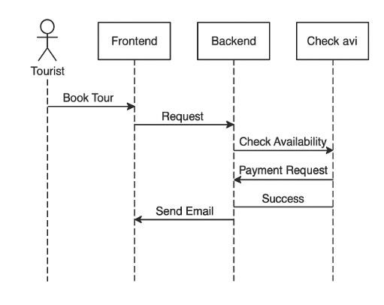

System Level Use Case Diagram

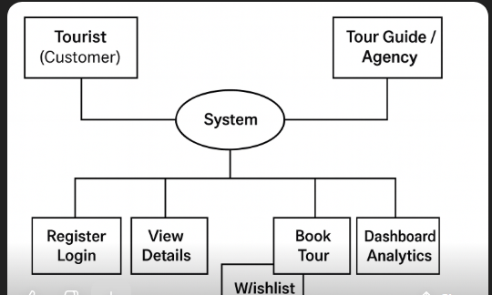
  - Activity Diagram – “Tourist Books a Tour
  - 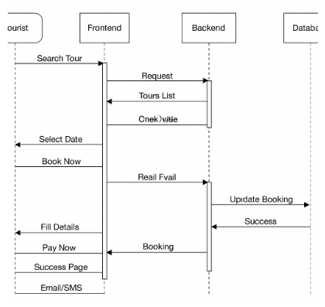
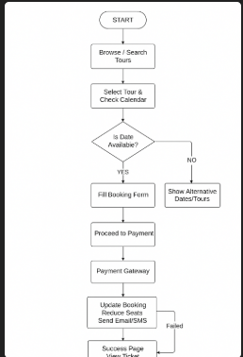

3. Sequence Diagram – Booking Process

4. Database ER Diagram (MongoDB Collections)
text
+-----------------+ +-----------------+
| Users | | Tours |
+-----------------+ +-----------------+
| _id |◄────┐ | _id |
| name | │ | title |
| email | │ | description |
| phone | │ | price |
| role | │ | duration |
| password | │ | maxGroupSize |
| isVerified | │ | guideId ─────┤
+-----------------+ │ | images[] |
│ | availableDates[]|
│ +-----------------+
│
+-----------------+ │ +-----------------+
| Bookings | └────│ Reviews |
+-----------------+ +-----------------+
| _id | | _id |
| tourId ────┤ | tourId ──────┤
| userId ───┤ | userId ────┤
| date | | rating |
| persons | | comment |
| totalAmount | +-----------------+
| paymentStatus |
| status |
+-----------------+

5. Class Diagram
text
+----------------+ +----------------+ +----------------+
| User | | Tour | | Booking |
+----------------+ +----------------+ +----------------+
| - _id: ObjectId| 1 * | - _id: ObjectId| * 1 | - _id: ObjectId|
| - name: String |------>| - title: String|<------| - tourId |
| - email: String| | - price: Number| | - userId |
| - role: String | | - guideId | | - date: Date |
| + login() | | + getDetails() | | + cancel() |
| + register() | +----------------+ +----------------+

4. References
https://www.natureadventureclub.pk/
https://ibex.com.pk/

